**Mobile development Project Document**

**NETFLIX**

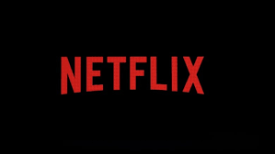

**SUBMITEED BY :**

**LOVEPREET KAUR C0739757**

**HARISH KUMAR C0738349**

**INTRODUCTION:**

Netflix is a streaming service that allows users to watch a wide variety of movies, documentaries and TV shows. This app is a demo of Netflix App.

**Requirements:**

* Operating system: android
* Android version: 4.4(KitKat) +
* Ram: 500MB

**Software:**

* Visual studio
* Xamarin
* MySQL lite

To access the videos, firstly the users have to Sign up their account and fill their details and the details will store in the database then, once the user sign up successfully then the users can login in the app by filling their details in the login page and able to access the Netflix App. If the details are not authentic there will be an error message.

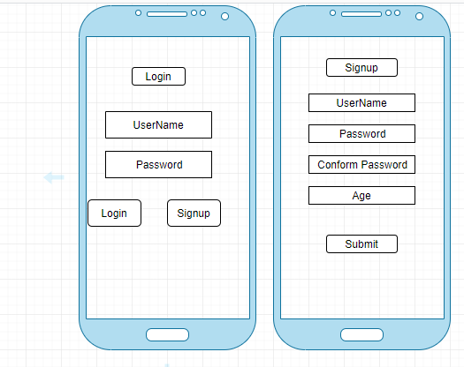

After Login, the user can see the number of categories of movies.

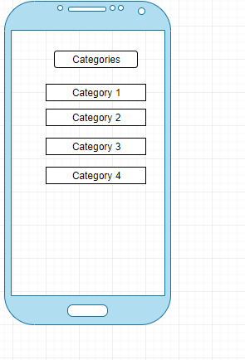

After selecting on category, user will able to access movie list.

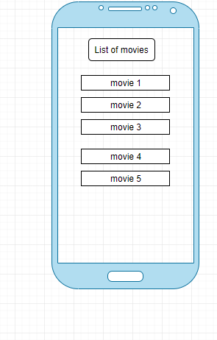

Once the user selects a movie then the user will be able to see the details of movies like, the description, number of views and rating about the movie.

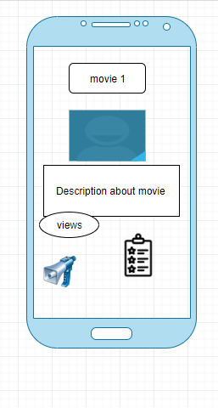

The user also able to make their own favorite list and by using tab user will access one and more favorite lists.

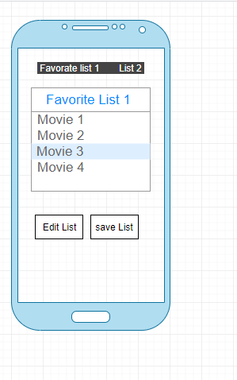

The users can edit and save their new list according to their choice.